Lab #5 – Matt Cunningham
Digital Electronics
Basic Gates with NAND Gates

Objectives:
- Use Quartus to build a logical circuit using NAND gates
- Proving De Morgan’s Theorem by building and making the circuit work
Equipment Used:
- Quartus 18.1 Software
Procedure:
- Create a new project in Quartus
- Configure Quartus settings
- Design the logic circuit:
  - Using 19 NAND gates
  - Using 2 inputs
  - Using 6 outputs
  - Following provided schematic
- Run the simulation to produce the timing diagram
- Create Boolean expressions for the circuit
- Create the truth table of the circuit
Results:

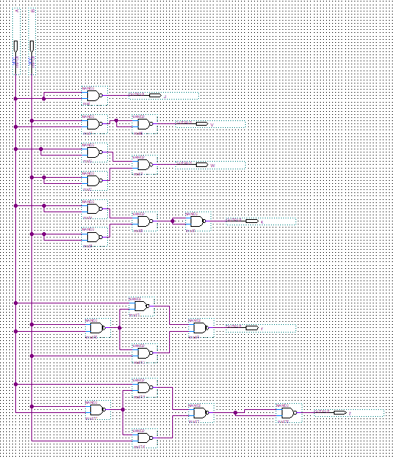

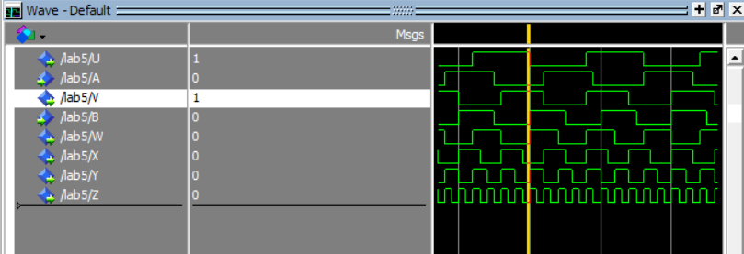

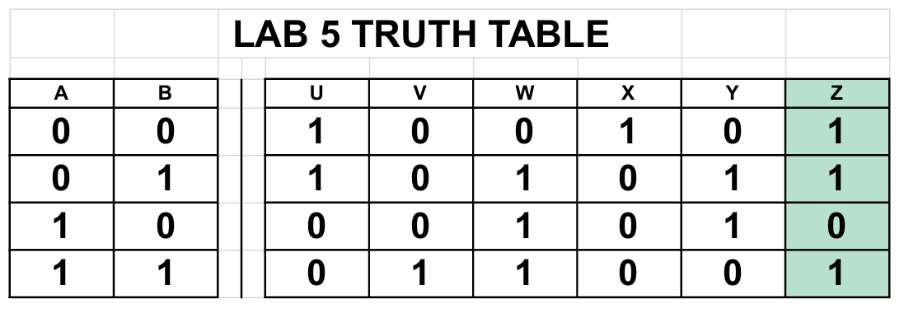
Conclusion:
We proved De Morgan’s theorem by generating the design file and proving that it is correct by writing the Boolean expressions and truth table

